**AUTONOMOUS AIR DUCT CLEANING ROBOT**

**MINI PROJECT REPORT**

**Submitted by**

**ARUNKUMAR K (113214120005)**

**BALAJI R (113214120008)**

**MADHUSUTHANAN M (113214120020)**

**in the partial fulfilment for award of the degree**

**Of**

**BACHELOR OF ENGINEERING**

**in**

**PRODUCTION ENGINEERING**

**DEPARTMENT OF PRODUCTION ENGINEERING**

**VELAMMAL ENGINEERING COLLEGE, SURAPET**

**ANNA UNIVERSITY, CHENNAI - 600 066**

**BONAFIDE CERTIFICATE**

Certified that this project report titled **“AUTONOMOUS AIR DUCT CLEANING ROBOT”** is the bonafide work of **ARUNKUMAR K (113214120005), BALAJI R (113214120008), MADHUSUTHANAN M (113214120020),** who carried out the project work under my supervision. Certified further, that to the best of my knowledge the work reported here in does not form part of any other project report or dissertation on the basis of which a degree or award was conferred on an earlier occasion on this or any other candidate.

**INTERNAL GUIDE,**

**Mr.P.Senthilkumar, M.E.Ph.D**

**Department of Production Engineering,**

**Velammal Engineering College,Chennai-66**

**ABSTRACT**

This project presents the design of an autonomous robot as a basic development of an intelligent wheeled mobile robot for air duct cleaning. The robot navigation is based on wall following algorithm. The robot is controlled using Arduino Microcontroller. Arduino Microcontroller guides the robot to move along a wall in a desired direction by maintaining a constant distance to the wall. Ultrasonic sensor is installed in the left side of the robot to sense the wall distance. The signals from these sensors are fed to Arduino Microcontroller which is used to determine the speed control of two DC motors. The robot movement is obtained through differentiating the speed of these two motors. The experimental results show that Arduino Microcontroller is successfully controlling the robot to follow the wall as a guidance line and has good performance.

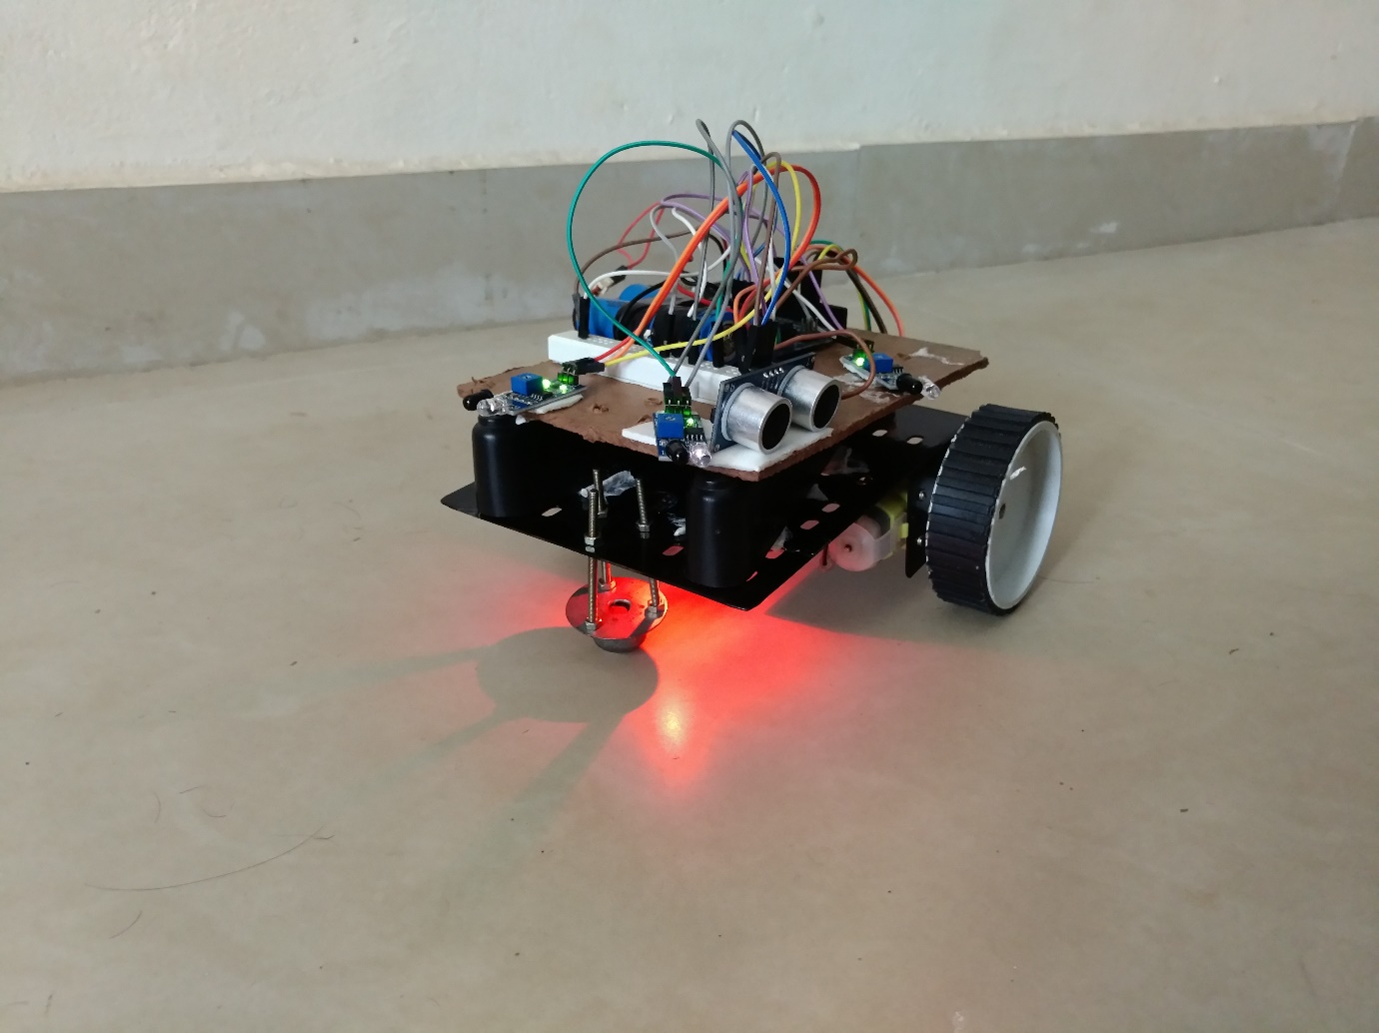

**CONTENT**

**1.INTRODUCTION -5**

**2.EQUIPMENTS LIST -5**

**3.MICROCONTROLLER -5**

**3.1. SUMMARY -6**

**4.SENSOR -6**

**5.IC L293D DRIVE -9**

**7.DC MOTOR & BALL CASTER -10**

**8.WORKING PROCEDURE -11**

**9.PROGRAM -11**

**10.WORKING MODEL -14**

**11.CONCLUSION -15**

**1.Introduction**

Autonomous robots are electromechanical devices that are programmed to achieve several goals. Air Duct Cleaning Robot uses Ultrasonic sensor, IR Sensor and two stepper motors as its actuator. The robot is controlled by an Arduino microcontroller. When the robot is allowed to move in a room or somewhere it can follow the wall in a Clockwise rotation, while keeping a particular distance from the wall. The overall objective of this project is to follow a wall on its left and maintain a constant distance with it. In general, the robotic chassis are designed carefully, so that they are balanced.

**2.Equipment List**

* Arduino Mega2560.
* IR Sensors
* UV Sensors
* DC Gear Motor with Wheels.
* DC Power Adapter (9V,2A)
* Ball Castor
* L293D Motor Driver
* Jumper wires

**3.Microcontroller:**

The Arduino Mega 2560 is a microcontroller board based on the ATmega2560 (datasheet). It has 54 digital input/output pins (of which 14 can be used as PWM outputs), 16 analog inputs, 4 UARTs (hardware serial ports), a 16 MHz crystal oscillator, a USB connection, a power jack, an ICSP header, and a reset button. It contains everything needed to support the microcontroller; simply connect it to a computer with a USB cable or power it with a AC-to-DC adapter or battery to get started. The Mega is compatible with most shields designed for the Arduino Duemilanove or Diecimila.

The Mega 2560 is an update to the Arduino Mega, which it replaces.

**3.1. Summary**

Microcontroller ATmega2560

* Operating Voltage 5V
* Input Voltage (recommended) 7-12V
* Input Voltage (limits) 6-20V
* Digital I/O Pins 54 (of which 14 provide PWM output)
* Analog Input Pins 16
* DC Current per I/O Pin 40 mA
* DC Current for 3.3V Pin 50 mA
* Flash Memory 256 KB of which 8 KB used by bootloader
* SRAM 8 KB
* EEPROM 4 KB
* Clock Speed 16 MHz

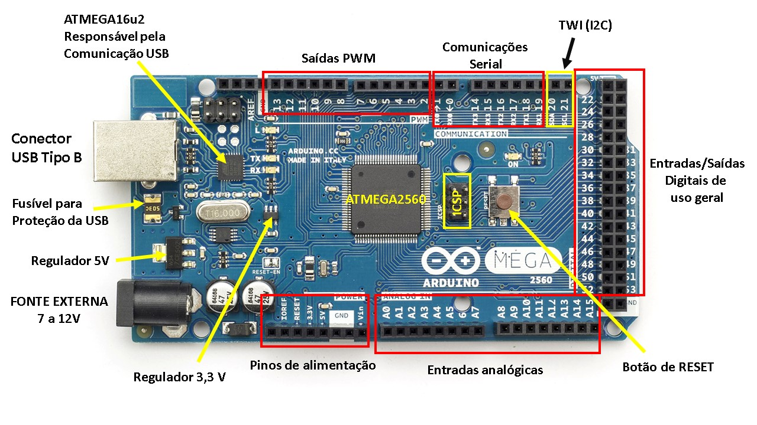

**4.Sensor Circuit:**

For Sensor Circuit, we have used a pair of IR Sensors. One is IR LED i.e. transmitter another is an IR Sensor i.e. photoreceiver. The basic principle of IR sensor is based on an IR emitter and an IR receiver. IR emitter will emit infrared continuously when power is supplied to it. On the other hand, the IR receiver will be connected and perform the task of a voltage divider. IR receiver can be imagined as a transistor with its base current determined by the intensity of IR light received. The lower the intensity of IR light cause higher resistance between collector-emitter terminals of transistor, and limiting current from collector to emitter. This change of resistance will further change the voltage at the output of voltage divider. In others word, the greater the intensity of IR light hitting IR receiver, the lower the resistance of IR receiver and hence the output voltage of voltage divider will decrease. Usually the IR emitter and IR receiver will be mounted side by side. Since the output voltage from voltage divider varies with the intensity of IR light pointing to a reflective surface. The further distance away between emitter and receiver decrease the amount of infrared light hitting the receiver if the distance between the sensor and a reflective surface is fixed. Since the output voltage from voltage divider varies with the intensity of IR light we have used analog Arduino input to measure the results to make the sensor take the readings. The values of the resistors are calibrated for better reading differences. These voltage differences readings are analog readings. Arduino has built in ADC which it converts to Digital. When the IR emitter falls on a white surface it gets reflected and the IR receiver receives the full IR intensity thus lower resistance between emitter and collector terminal causing flowing of current and resulting a larger voltage. But when it falls on a black or similar surface IR is absorbed and the receiver receives a lot less IR resulting increase of resistance between the emitter and collector terminal causing limiting of current thus the output voltage. These voltage changes are ranged between (1-1024) as the analog outputs of Arduino are 10 bit resolutions. We differentiated the analog values in order to get our required results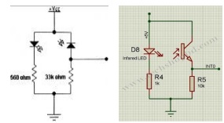

**Ultrasonic Sensor:**

An Ultrasonic sensor is a device that can measure the distance to an object by using sound waves. It measures distance by sending out a sound wave at a specific frequency and listening for that sound wave to bounce back. By recording the elapsed time between the sound wave being generated and the sound wave bouncing back, it is possible to calculate the distance between the sonar sensor and the object.

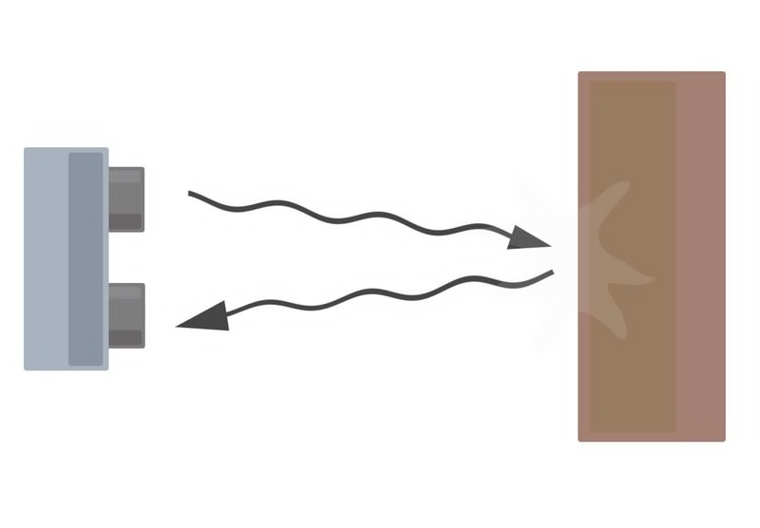

Diagram of the basic ultrasonic sensor operation

Distance = (speed of sound x time taken)/ 2

Since it is known that sound travels through air at about 344 m/s (1129 ft/s), you can take the time for the sound wave to return and multiply it by 344 meters (or 1129 feet) to find the total round-trip distance of the sound wave. Round-trip means that the sound wave traveled 2 times the distance to the object before it was detected by the sensor; it includes the 'trip' from the sonar sensor to the object AND the 'trip' from the object to the Ultrasonic sensor (after the sound wave bounced off the object). To find the distance to the object, simply divide the round-trip distance in half.

It is important to understand that some objects might not be detected by ultrasonic sensors. This is because some objects are shaped or positioned in such a way that the sound wave bounces off the object, but are deflected away from the Ultrasonic sensor. It is also possible for the object to be too small to reflect enough of the sound wave back to the sensor to be detected. Other objects can absorb the sound wave all together (cloth, carpeting, etc.), which means that there is no way for the sensor to detect them accurately. These are important factors to consider when designing and programming a robot using an ultrasonic sensor.

**5.IC L293D Drive motor:**

The most common method to drive DC motors in two directions under control of a computer is with an H-bridge motor driver. H-bridges can be built from scratch with bi-polar junction transistors (BJT) or with field effect transistors (FET), or can be purchased as an integrated unit in a single integrated circuit package such as the L293. The L293 is simplest and inexpensive for low current motors, for high current motors, it is less expensive to build your own H-bridge from scratch. Motor driver is basically a current amplifier which takes a low-current signal from the microcontroller and gives out a proportionally higher current signal which can control and drive a motor. In most cases, a transistor can act as a switch and perform this task which drives the motor in a single direction. Turning a motor ON and OFF requires only one switch to control a single motor in a single direction. But by reversing its polarity motor control in both direction is achievable.

This can be achieved by using four switches that are arranged in an intelligent manner such that the circuit not only drives the motor, but also controls its direction. Out of many, one of the most common and clever design is a H-bridge circuit where transistors are arranged in a shape that resembles the English alphabet "H".

The circuit has four switches A, B, C and D. Turning these switches ON and OFF can drive a motor in different ways. 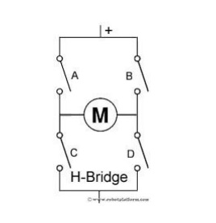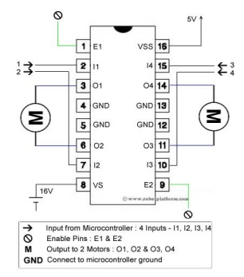

1. Turning on Switches A and D makes the motor rotate clockwise

2. Turning on Switches B and C makes the motor rotate anti-clockwise

3. Turning on Switches A and B will stop the motor (Brakes)

4. Turning off all the switches gives the motor a free wheel drive

5. Lastly turning on A & C at the same time or B & D at the same time shorts your entire circuit. So, do not attempt this.

L293D IC generally comes as a standard 16-pin DIP (dual-in line package). This motor driver IC can simultaneously control two small motors in either direction; forward and reverse with just 4 microcontroller pins.

**7.DC Motor with Wheels & Ball Caster:**

**Motor Specifications**

**Operating voltage:** 3V ~ 6V DC (recommended value 5V)

**Maximum torque:** 800g.cm

**Speed without load:** 90±10rpm

**Reduction ratio:** 1:48

**No Load current:** 190mA (max.250mA)

**8.Working Procedure**

Autonomous Air Duct Cleaning Robot has two wheels on either side of its chassis. Each of these wheels has a separate DC motor. These motors run independently from each other with the help of PWM signals generated by the Arduino Microcontroller, and a driver IC L293D. Moreover, a caster wheel is used in to balance the entire chassis. The robot measures the distance from a wall on its left side. Two ultrasonic sensors are installed on the left side to aid in following a wall.

The outputs of the sensor circuits are connected to the analog inputs of the Arduino board. The motor driver IC inputs are taken from four Arduino digital PWM pins and the outputs are connected to the motors. Taking analog based (1-1024) readings from the sensors the Arduino is programmed to control the motor based on the readings.

If robot is between 15 and 20 cm from the wall, then left wheel speed is decreased with a larger amount. Similarly, if robot is between 6 and 8 cm from the wall, then the left wheel speed is increased. IR sensor is used to measure the presence of obstacles in its path.

**9.Program**

**\\ Program for robot**

long duration1,duration2, s1;

int enA = 5;

int in1 = 6;

int in2 = 7;

// motor two

int enB = 11;

int in3 = 9;

int in4 = 10;

void setup()

{

Serial.begin (9600);

pinMode(12, OUTPUT);

pinMode(A0, INPUT);

pinMode(enA, OUTPUT);

pinMode(enB, OUTPUT);

pinMode(in1, OUTPUT);

pinMode(in2, OUTPUT);

pinMode(in3, OUTPUT);

pinMode(in4, OUTPUT);

}

void loop()

{

digitalWrite(12, LOW);

delayMicroseconds(.5);

digitalWrite(12, HIGH);

delayMicroseconds(1);

digitalWrite(12, LOW);

duration1 = pulseIn(A0, HIGH);

s1 = duration1/58.2;

Serial.println(s1);

int A= analogRead(A1);

int B= analogRead(A2);

int C= analogRead(A3);

int a,b,c;

a=Serial.println(A);

b=Serial.println(B);

c=Serial.println(C);

delay(1);

if(s1>12) // turn left

{

digitalWrite(in1, HIGH);

digitalWrite(in2, LOW);

digitalWrite(in3, HIGH);

digitalWrite(in4, LOW);

analogWrite(enA, 70);

analogWrite(enB, 500);

}

if(s1<7) // Turn right

{

digitalWrite(in1, HIGH);

digitalWrite(in2, LOW);

digitalWrite(in3, HIGH);

digitalWrite(in4, LOW);

analogWrite(enB, 70);

analogWrite(enA, 500);

}

if((s1>7)&&(s1<12)) // Forward

{

digitalWrite(in1, HIGH);

digitalWrite(in2, LOW);

digitalWrite(in3, HIGH);

digitalWrite(in4, LOW);

analogWrite(enB, 500);

analogWrite(enA, 500);

}

if((A<200)||(B<200)||(C<200)) // turn right

{

digitalWrite(in1, HIGH);

digitalWrite(in2, LOW);

digitalWrite(in3, LOW);

digitalWrite(in4, HIGH);

analogWrite(enA, 500);

analogWrite(enB, 500);

}

}

**10.Working Model**

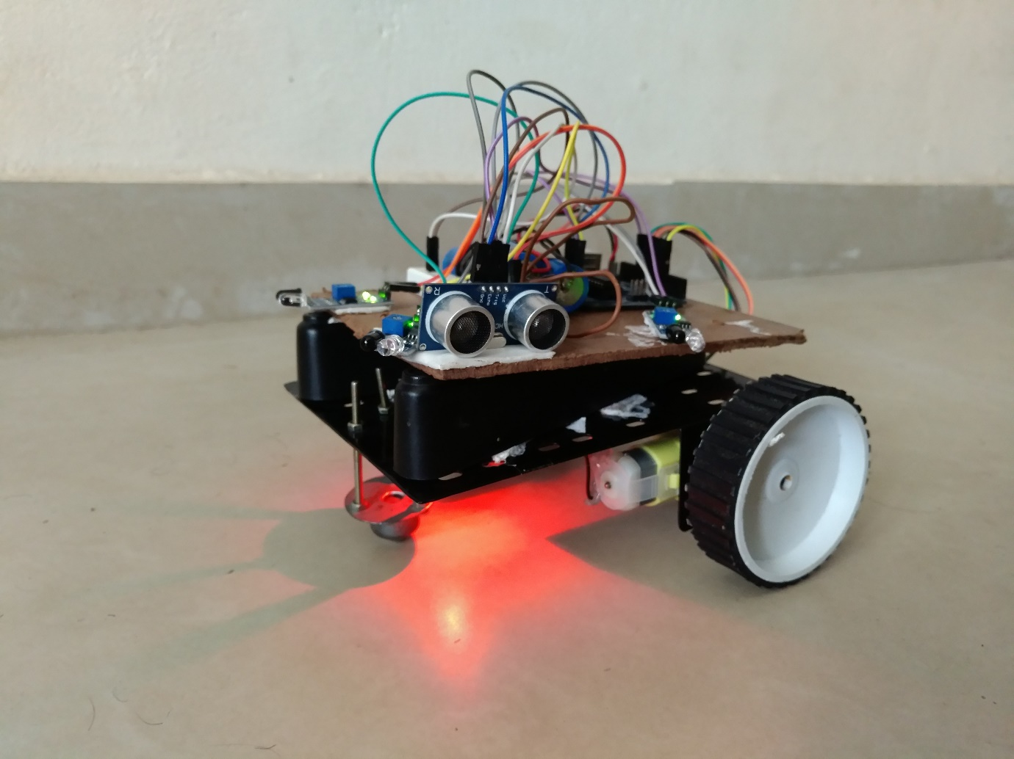

**11.Conclusion**

In this report, a differential drive mobile robot is presented which is controlled with the help of an Arduino controller to maintain a constant distance from the wall. Moreover, a few sensors can be mounted on the right side of the robot, so that robot can travel through narrow paths like in the corridor. A further research can be done where better sensors can be used.